**Task Week 4**

**1. Model Development:**

* The project utilizes **machine learning algorithms** and addresses the class imbalance issue using **imbalanced-learn**. This toolkit helps by:
  + **Over-sampling** the minority class or **under-sampling** the majority class to create a balanced dataset.
  + Class distribution is measured both before and after resampling, ensuring that the balancing is effective.
* Machine learning models are built using **scikit-learn**, potentially including models like logistic regression, decision trees, or random forests (though specific models need to be verified from the code).
* Data preprocessing steps likely involve **pandas** for cleaning and organizing the dataset, and **numpy** for numerical computations.

**2. Pipeline Integration:**

* **Lambda Functions**: The project integrates **AWS Lambda** functions, which are used to invoke the model by fusing its endpoints. Lambda functions are lightweight, serverless compute services that trigger the model when an event (like an API request) occurs.
* **API Creation**: An API has been created to trigger these Lambda functions, allowing external services or applications to invoke the machine learning model in a scalable and serverless way.
* **Endpoint Fusion**: The model endpoints are combined (fused) to streamline the process of accessing the model, making the API trigger an efficient mechanism to run the model predictions.

This design ensures that the model can be invoked without needing a dedicated server, improving scalability, and reducing costs. The API-to-Lambda function setup also ensures high availability and flexibility.

**3. Deployment:**

* Although deployment specifics are not fully outlined, the inclusion of Lambda functions and an API suggests a cloud-based, serverless deployment approach.
* This architecture would enable the model to be deployed in a highly scalable environment where the API triggers the machine learning model whenever a request is made.

**Model performance :**

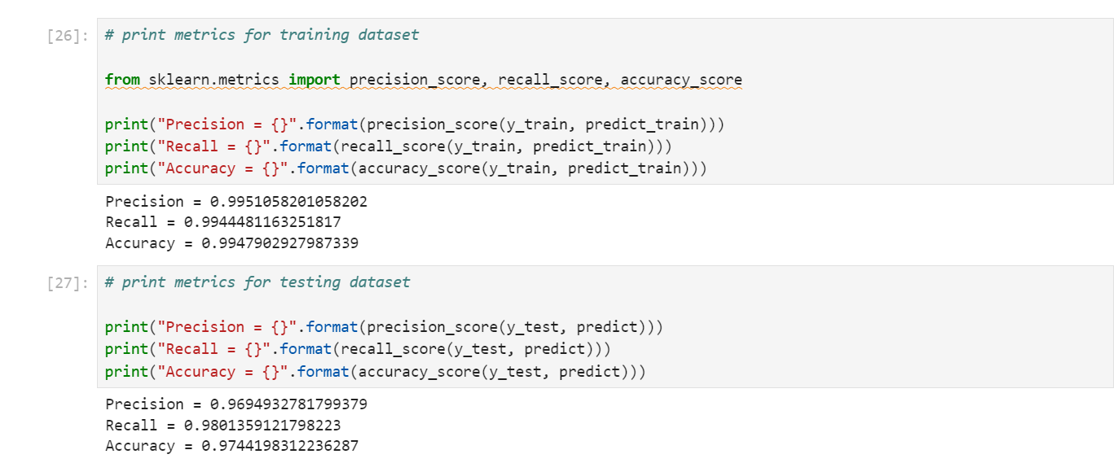

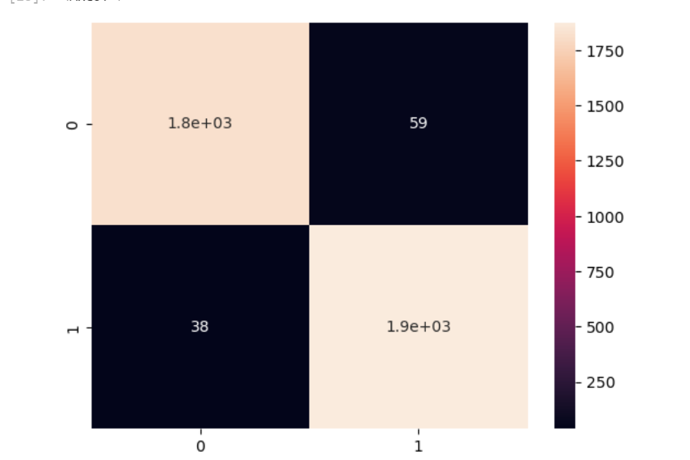

Live demo of the deployed system :

[project demonstration video](https://drive.google.com/file/d/1f7GdayTmKMz5xLoiv70tQy4seWhmn_jl/view?usp=sharing)